Track Builder
Activity: Make a structure to support a rail track out of everyday materials like lollipop sticks and clothes pegs.
Target Age: 4-14 years old
Curriculum links & skills: Science, technology, mathematics, geography. Communication, creativity, evaluation, organisation, problem solving and team working.
Background:
The track for a high speed train has to be straight and level. If there are too many turns, or the train has to go up or down a hill it will have to slow down. If your children can ride a bicycle then talk to them about how they have to brake when they get to a corner.
Our country is full of obstacles – from hills, rivers and parks to roads, towns and airports. Sometimes we have to build tunnels, bridges, embankments and cuttings so that our track can get past these obstacles while staying in a straight line.
Equipment needed:
- “straights”: e.g. lollipop sticks, playing cards or straws
- “joiners”: e.g. binder clips, clothes pegs, elastic bands
- obstacles: e.g. different size boxes, egg boxes, folders
- optional: Wooden train track “straights” and a model train
Instructions:
Children use everyday objects like lollipop sticks, clips and clothes pegs to build a support for a section of track over, through or under an obstacle, or between two obstacles.
If you have a wooden train set or similar, children can then put the wooden track straights on their support and see if the train safely gets over their obstacle.
This activity was designed to be sustainable by choosing reusable materials, so that structures can be taken apart when children have finished. However, it could also be done using paper, card, sticky tape and glue.
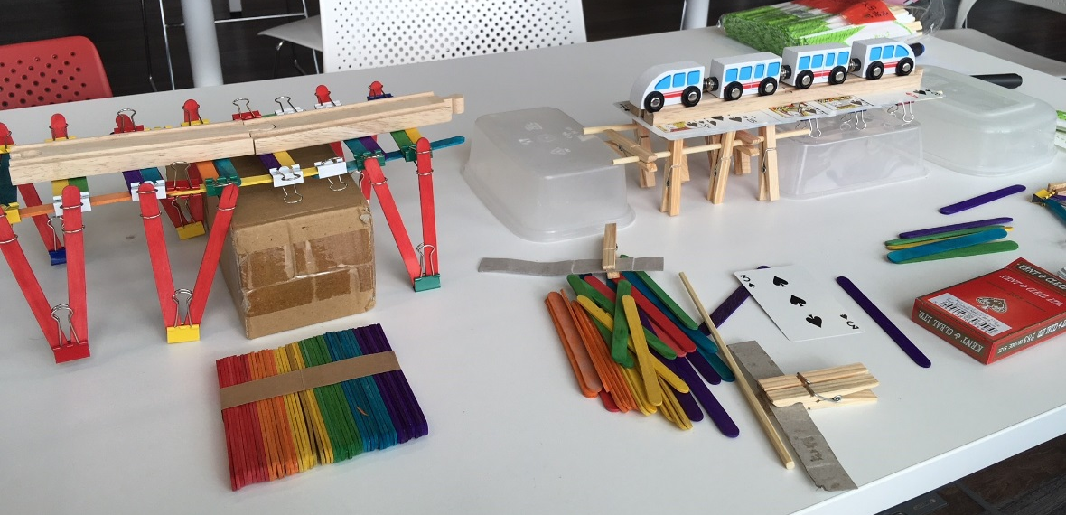
Explanation:
When building any structure – from a house to a railway track, engineers have to understand the ground conditions. Factors like the steepness of the ground, the type of soil or rock affect how the structure is built.
Children will find that building their track on some surfaces (e.g. a box) is much easier than others (e.g. a squashy foam sheet).
You can find out more about how engineers at HS2 are investigating ground conditions and using the information to inform design on our YouTube channel.

